Day in the Life of the Hudson River 10/14/21
DENNINGS POINT, BEACON
RIVER MILE: 60
Salt Front: ~ RM 49
South Avenue School – Aaron Burke and 5 teachers
40 students 5th grade
Clarkson University’s Beacon Institute for Rivers and Estuaries- Bridget Walsh
Latitude 41.49147 N & Longitude – 73.98506 W
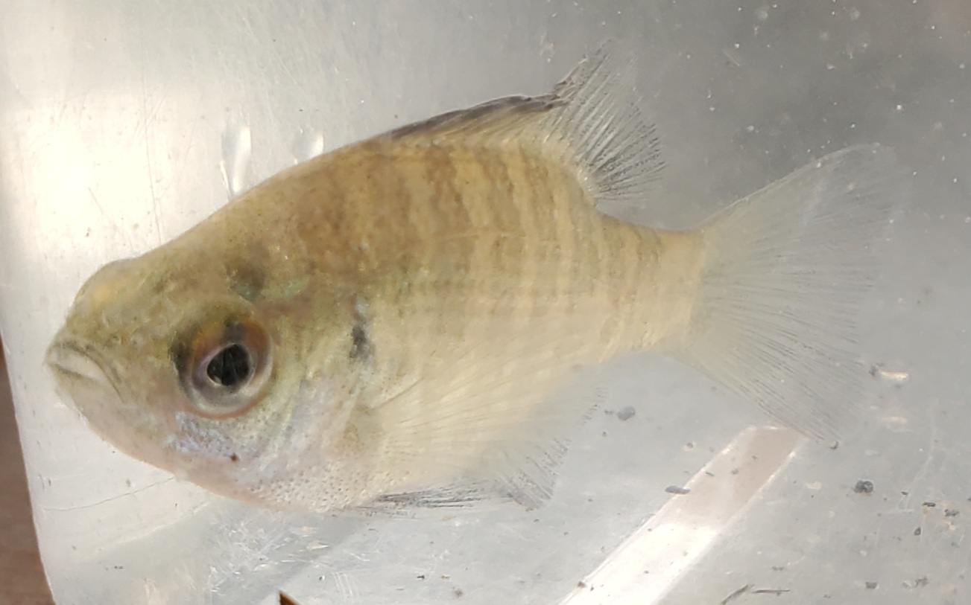 | 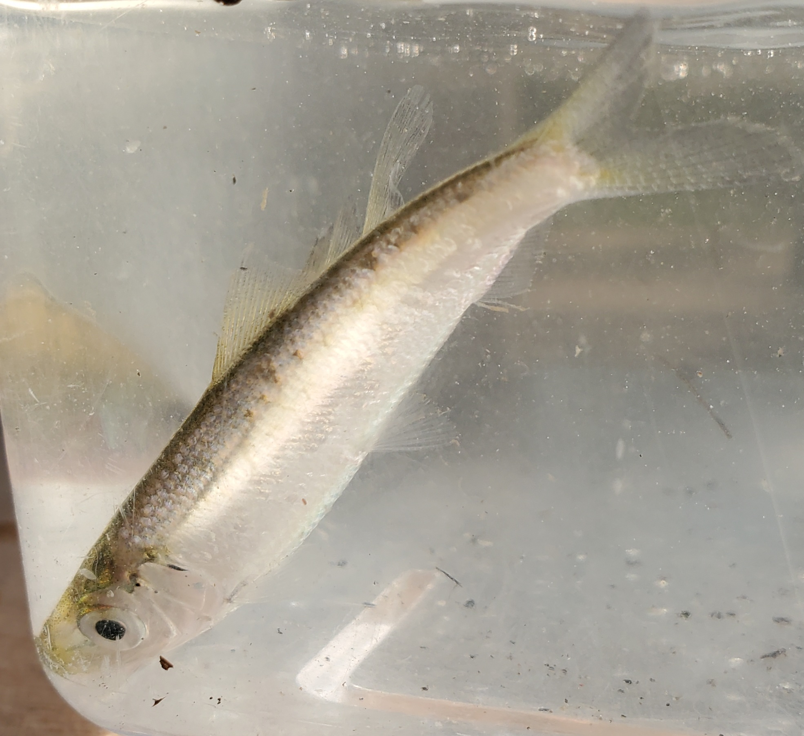

Location: Dennings Point, 200 yards south of Long Dock Rd. Parking Lot, Beacon, Dutchess County
Area: Nature preserve with few buildings. Believe area mostly used for sightseeing and fishing. Beach area.
Sampling Site: Forested, beached, pipe entering water, covered with vegetation, rocky & sandy
Surrounding Land Use:, 30% forested; 70% beach
Shoreline: 15% Sandy, 15% Muddy, 70% Rocky
River Bottom: muddy, sandy, rocky
Water: Calm

ITEM |  |  | Time |  | Reading |  |  |  |  | Comments
Physical
Air Temperature |  |  | 10:40 AM  11:45 AM  12:45 PM |  | 18.89 º C  20 º C  22.78 º C |  |  | 66 º F  68 º F  73 º F
Wind Speed: |  |  | 11:45 AM |  | 5 mph |  |  | Beaufort 2
Weather today |  |  | 10:50 AM – clear <25%, no rain
Weather the past 3 days: |  |  | Mornings begin foggy but by early morning, mid-afternoon, clear skies, temperatures in the 70s
Tides- tide stick |  |  | Time |  | Rising, Falling, Unchanged |  |  | Height (cm)
 |  |  | 10:30 AM  11:45 AM |  | -  Falling |  |  | 50 cm  35.5 cm
Current- |  |  | Time |  | Cm/sec |  | Knots | North/South |  | Ebb/Flood/Still
 |  |  | NA
Water Temperature- 2 ft depth |  |  | 10:40 AM |  | 16.67 º C |  |  | 62 º F
Turbidity- |  |  | NA
Chemical
Salinity -No Quantabs |  |  | NA
DO – Chemetrics kit |  |  | Time |  | Temp |  |  | ppm DO |  | % saturation
 |  |  | 10:38 AM  11:15 AM  12:30 PM |  | 16.67 º C  16.67 º C  16.67 º C |  |  | 6 ppm  7 ppm  8 ppm |  | 60%  70%  81%
pH – test strips. Color match kit |  |  | 11:00 AM |  | 7, 7.5, 7.5, |  |  |  |  | Avg: 7.3
Biological
Fish- Seine |  | Number |  |  | Name |  |  | Length of longest |  | Length of smallest
4 seines - 10:10 AM, 10:25AM, 11:15 AM, and 11:40 AM |  | 200  1  1 |  |  | Blueback Herring  Channel Catfish  Bluegill Sunfish |  |  | 6.4 cm  25 cm  5.1 cm |  | 3.8 cm
Fish Totals |  | TOTAL: 202 |  |  | Diversity: 3
Macroinvertebrates |  | Number |  |  | Name |  |  | Length of longest |  | Length of smallest
NR |  | NR |  |  | NR
Macroinvertebrate Totals |  | TOTAL: |  |  | Diversity:
Boats
 | Time |  |  | Name |  | Color |  | North/Southbound |  |  | Light/Loaded
Commercial | 10:30 AM  12:15 PM |  |  | Large Boat  Large Boat |  | Black/Red  Black/Red |  | North  North |  |  | Light  Loaded
Recreational | 10:45 AM |  |  | Small Private |  |  |  | South |  |  | Light

